**DTC Offline Programmer Validation**

Contents

General Test 2

Configuring the COM Port 16

Changing Test Limits 17

Viewing Test Results 18

# General Test

Upon start-up of the application, the user is prompted with the initial form below:

Select the part number of the DTC product that’s being tested e.g. 50641300 – MLX90327 Dual Probe.

Select the DUT Port which it is connected to at the back of the CoHap rack.

If the CoHap rack fails to connect to the part or it fails to read data from the part, then the main form appears like below:

If the CoHap rack connection to the part is successful and EEPROM read of the part is successful then the following sequence form appears instead:

The program state shows the program settings that are set up currently on the DTC part selected.

Choose the sequence you’d like to run on the part.

If the part is being programmed, an option of initial or final settings is made visible.

If initial settings are being set, an option to set the part number and serial number on the part is also offered.

If you wish to include programming of the serial ID and ASIC part number, then the following parameters need to be entered:

The cancel button provides the option to stop the test and run another part or stop the test. The start button will appear when the sequence selected is valid and can be run. If not, the start button is disabled.

When the start button is clicked, the sequence selected is run and the main form appears. The ‘About’ section provides details of the part that is run, and the sequence selected. The current is always checked first and then the sequence selected is run.

When testing the part, the number of probe values seen for temperature and RISO depends on the number of probes there are for the DTC part.

The status of the sequence can be seen in the bottom left corner, as seen in the following images:

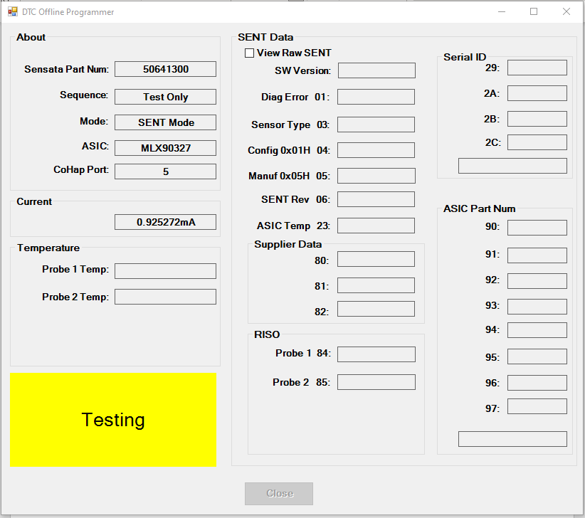

Testing results may be different depending on the program state of the part and whether it is a SENT or PWM part.

If the part is a PWM part and has final settings programmed, the test results will differ, and the SENT data won’t be visible.

If the parts have Initial settings programmed or they aren’t a PWM part, the part is always in SENT mode and therefore the SENT data will be visible when testing.

When the ‘View Raw SENT’ box is ticked, this shows the raw hex values for the ASIC Die Temp and RISO values. Unticked, it shows the values in degrees.

If some values aren’t logged on the SENT channel, the values are filled with a ‘- ‘.

When the sequence is aborted or we’ve got to the end of testing a part, a message appears prompting the users with an option to test another part or stop the test.

# Configuring the COM Port

Search for the control panel on your PC.

Go to Device manager and open the Ports tab to check what port your CoHap rack is connected to.

Open the file: C:\ST\Config\Setup.config

Inside the file, change the COM Port number to the COM port which the CoHap rack is connected to.

# Changing Test Limits

Open the file: C:\ST\Config\TestLimits.ini

Change the values of the limits accordingly.

# Viewing Test Results

Install Microsoft SQL server management studio on your PC if it isn’t already installed.

Upon opening the application, connect to the server where the database is stored. Select the local server if it isn’t already selected. This is where the database results are stored.

Go to databases -> CSTemplate.Classes.DTCDb -> Tables.

At the bottom of tables, the two databases relevant are dbo.DTCDatas and dbo.Failcodes.

Right click on them and click ‘select top 1000 rows’.

The test results are visible, and queries can be run to filter the data.

The failcodes database refers to the failcodes column in the DTCData database. It provides a description for the failcodes to understand the reason a test failed.